

MOI HIGH-KABARAK 2025 PREDICTION
Kenya Certificate of Secondary Education
KCSE PREDICTION SERIES 1
231/2 Biology (Theory) Paper 2
Time: 2 Hours

NAME…………………………………………………………………………………………
SCHOOL……………………………………………… SIGN…………………………..
INDEX NO……………………………………………. ADM NO………………………

Kenya Certificate of Secondary Education.

INSTRUCTIONS TO CANDIDATES
1. Write your name and index number in the spaces provided above.
2. Sign and write the date of examination in the spaces provided above.
3. This paper consists of Two sections A and B.
4. Answer ALL the questions in section A in the spaces provided.
5. In section B answer question 6 (compulsory) and either 7 or 8 in the spaces provided.

FOR EXAMINERS USE ONLY.
SECTION | QUESTIONS | MAXIMUM | SCORE
A | 1-5 | 40
B | 6  7  8 | 20  20  20
 | TOTAL | 80

SECTION A (40 MARKS)
Answer ALL the questions in this section in the spaces provided.
- The flow diagram below represents passage of a meal through the human digestive system. Study the diagram and answer the questions that follow.

Digestive juice A
Ugali and Meat stew
Mouth cavity
Stomach
Digestive juice B

Ileum
Digestive juice C

- Name the physical process that will occur in mouth cavity (1mk)
………………………………………………………………………………………………………

- Name the digestive juices B and C (2mks)
B…………………………………………………….
C…………………………………………………….

- Explain two ways in which the digestive system is protected from corrosive effects of digestive juices. (2mks)
………………………………………………………………………………………………………
………………………………………………………………………………………………………
………………………………………………………………………………………………………

- Name the hormone that stimulate secretion of juice B. (1mk)
………………………………………………………………………………………………………

- Identify two contents of digestive juice A (2mks)
………………………………………………………………………………………………………
………………………………………………………………………………………………………

- Examine the diagram below and answer the questions that follows
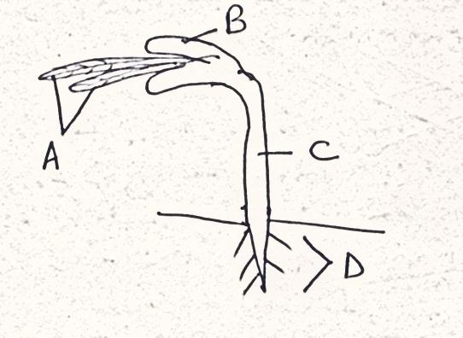
Name the parts labeled A-D (4mks)
A………………………………………………………………………………………………..
B…………………………………………………………………………………………………
C………………………………………………………………………………………………….
D…………………………………………………………………………………………………..

- State the type of germination exhibited by the seedling above (1mk)
………………………………………………………………………………………………………

c) State and explain three environmental conditions necessary for germination. (3 marks)
………………………………………………………………………………………………………
………………………………………………………………………………………………………
………………………………………………………………………………………………………
………………………………………………………………………………………………………
………………………………………………………………………………………………………

3. A cross between a red flowered plants and white flowered plants produced plants with pink flowers. Using letter R to represent the gene for red color and W for white.
- What were the parental genotypes? (2mks)
………………………………………………………………………………………………………
………………………………………………………………………………………………………

- Work out the cross between f1 generations (4mks)

- State the phenotypic and genotypic ratios of the f2 generations (2mks)
………………………………………………………………………………………………………
………………………………………………………………………………………………………
………………………………………………………………………………………………………

4. (a) What is meant by:
- Autecology (1mk)
………………………………………………………………………………………………………
………………………………………………………………………………………………………
- Synecology (1mk)
………………………………………………………………………………………………………
………………………………………………………………………………………………………

(b) Using the table below, answer the questions that follow
 | Number of stomata
Leaf | Upper epidermis | Lower epidermis
A | 300 | 0
B | 150 | 200
C | 02 | 13

c) Suggest the possible habitat of the plants from the leaves were obtained (3mks)
A
………………………………………………………………………………………………………
B
……………………………………………………………………………………………………....
C
………………………………………………………………………………………………………

d) State the modifications in the stomata of leaf C (3mks)
………………………………………………………………………………………………………
………………………………………………………………………………………………………
………………………………………………………………………………………………………
………………………………………………………………………………………………………
………………………………………………………………………………………………………

5. The diagram below shows a section through the mammalian skin
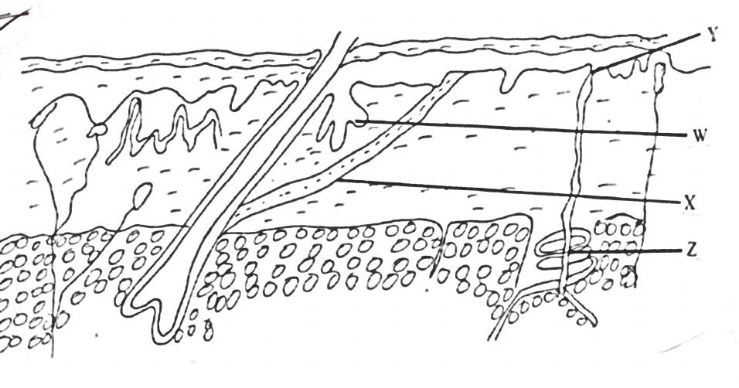

- Name the parts labeled Y and X (2mks)
X……………………………………………………………………………………………

Y……………………………………………………………………………………………

- State the function of the parts labeled W and Z (2mks)
W…………………………………………………………………………………………………
………………………………………………………………………………………………………
Z……………………………………………………………………………………………………
………………………………………………………………………………………………………

- Explain the changes that occur on the skin when it is cold (4mks)
………………………………………………………………………………………………………
………………………………………………………………………………………………………
………………………………………………………………………………………………………
………………………………………………………………………………………………………
………………………………………………………………………………………………………
………………………………………………………………………………………………………

SECTION B: (40MKS)
QUESTION 6 is COMPULSARY: Answer either question 7 or 8.
- In an experiment, three healthy rabbits were fed with equal amounts of carbohydrates. After 1 hour their blood sugar glucose concentration was measured at 30 minutes intervals for 3 hour. The results are as shown in the table below.
Glucose conce Mg/ml Rabbit | Initial time(minutes) | 30 Minutes | 60Minutes | 90 Minutes | 120 Minutes | 150 Minutes | 180 Minutes
P | 1.6 | 1.55 | 1.43 | 1.36 | 1.3 | 1.19 | 1.11
Q | 1.49 | 1.39 | 1.34 | 1.32 | 1.27 | 1.2 | 1.09
R | 1.59 | 1.39 | 1.33 | 1.27 | 1.18 | 1.1 | 0.99
Mean | 1.56 | 1.44 |  | 1.32 | 1.25 | 1.16 | -

a.(i) Calculate the mean glucose concentration 1mg/ml of blood at 60 and 180 minutes. (2mks)

(ii) On the grid provided plot a graph of mean glucose concentration against time. (6mk)

(iii) What was the mean concentration in the blood after 75minutes? (1mks)
………………………………………………………………………………………………………
………………………………………………………………………………………………………
(iv)Why was it necessary to use 3 rabbits in the experiment? (1mks)
………………………………………………………………………………………………………
………………………………………………………………………………………………………
(v) Account for differences in mean glucose concentration between initial time and 180 minutes. (3mks)
………………………………………………………………………………………………………
………………………………………………………………………………………………………
………………………………………………………………………………………………………
………………………………………………………………………………………………………
………………………………………………………………………………………………………

(b) Name three products of digestion other than glucose (3mks)
………………………………………………………………………………………………………
………………………………………………………………………………………………………

(c) What is the fate of excess glucose in:
(i) Plants? (2mks)
………………………………………………………………………………………………………
………………………………………………………………………………………………………
………………………………………………………………………………………………………
………………………………………………………………………………………………………

(ii) Animals ? (2mks)
………………………………………………………………………………………………………
………………………………………………………………………………………………………
………………………………………………………………………………………………………
………………………………………………………………………………………………………

7. Describe how the male reproductive system is adapted to its functions. (20mks)

8(a) How are structures of the human eye adapted to their functions (14 marks)
(b) State three defects of the eye and how each can be corrected (6 marks)

………………………………………………………………………………………………………
………………………………………………………………………………………………………
………………………………………………………………………………………………………
………………………………………………………………………………………………………
………………………………………………………………………………………………………
………………………………………………………………………………………………………
………………………………………………………………………………………………………
………………………………………………………………………………………………………
………………………………………………………………………………………………………
………………………………………………………………………………………………………
………………………………………………………………………………………………………
………………………………………………………………………………………………………
………………………………………………………………………………………………………
………………………………………………………………………………………………………
………………………………………………………………………………………………………
………………………………………………………………………………………………………
………………………………………………………………………………………………………
………………………………………………………………………………………………………
………………………………………………………………………………………………………
………………………………………………………………………………………………………
………………………………………………………………………………………………………
………………………………………………………………………………………………………
………………………………………………………………………………………………………
………………………………………………………………………………………………………
………………………………………………………………………………………………………
………………………………………………………………………………………………………
………………………………………………………………………………………………………
………………………………………………………………………………………………………
………………………………………………………………………………………………………
………………………………………………………………………………………………………
………………………………………………………………………………………………………
………………………………………………………………………………………………………
………………………………………………………………………………………………………
………………………………………………………………………………………………………
………………………………………………………………………………………………………
………………………………………………………………………………………………………
………………………………………………………………………………………………………
………………………………………………………………………………………………………
………………………………………………………………………………………………………
………………………………………………………………………………………………………
………………………………………………………………………………………………………
………………………………………………………………………………………………………
………………………………………………………………………………………………………
………………………………………………………………………………………………………
………………………………………………………………………………………………………
………………………………………………………………………………………………………
………………………………………………………………………………………………………
………………………………………………………………………………………………………
………………………………………………………………………………………………………
………………………………………………………………………………………………………
………………………………………………………………………………………………………
………………………………………………………………………………………………………
………………………………………………………………………………………………………
………………………………………………………………………………………………………
………………………………………………………………………………………………………
………………………………………………………………………………………………………
………………………………………………………………………………………………………
………………………………………………………………………………………………………
………………………………………………………………………………………………………
………………………………………………………………………………………………………

